*LAB # 05*

*LAB task*

1. *Write an assembly program that Read and print your rollno*

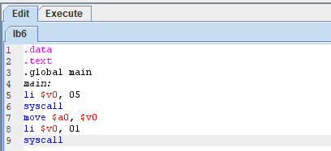

***Output:***

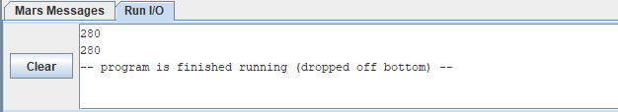

1. *Write an assembly program that read and print last alphabet of your name*

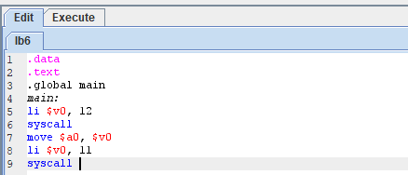

***Output:***

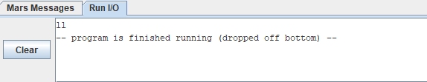

1. *Write an assembly program that read and print your full name*

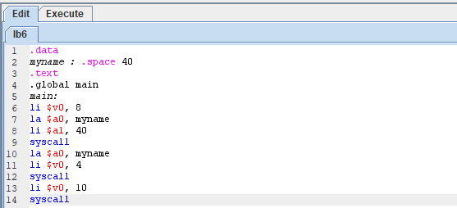

***Output:***

